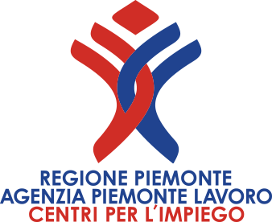
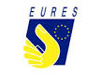

Timisoara - Romania
Multinational Company is looking for

15 CUSTOMER SUPPORT ASSOCIATE
ITALIAN MOTHER TONGUE AND ENGLISH LEVEL B2/C
Requirements and duties to be performed:
Italian mother tongue, English level B2/C
Strong computer skills
Skilled in multitasking and ability to rotate shift
Offer additional products and/or services
Track, document and retrive information in call tracking database
Respond to custode inquiries by referring them to published materials, secondary sources or more senior staff
Clarify custode requirements, use decision-support tools and resources to appropriately provide resolution to the custode
Listen attentively to custode needs and concerns; demonstrate empathy while maximizing opportunity to build rapport with the custode
Prepare complete and accurate work including appropriately notating accounts as requie
Participate in activities designed to improve custode satisfaction and business performance
Conditions:
Permanent contract,40 h. per week; salary gross Ron 5.150 monthly + gift vouchers for Eeaster and Christmas. Travel assistance, relocation assisted, meal tickets, sport bonus, medical services
How to apply:
Send your complete and updated Curriculum in English to:
eures@agenziapiemontelavoro.it
Application deadline: 4 June 2019
SELECTION DAY IN TURIN: 5 June 2019

