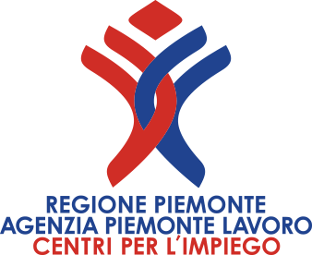


Denmark

International Company are looking for

1 Foundry Manager
Duties:
As a Foundry Manager you will be overall responsible for the Core department, Furnaces, two DISA lines and Wagner SINTO Horizontal line. You will have a central position and work within the areas; material qualities, melting process, casting process in cooperation with skilled colleagues, suppliers and cooperation partners.
With your line managers you have to focus on systematic continuous improvements in efficiency, scrap development from the lines. Further you ensure improvement of the products, processes, systems, procedures and instructions.
We expect, that you:
- have an education and work experience as foundry engineer or metallurgist or has acquired similar proficiency via job experience
- as a minimum have good command of English in speaking and writing
- will move your permanent residence to Aars, Nordjylland area
- can work independently and show initiative
We offer:
- an interesting and challenging job with high responsibility
- co-operation with competent colleagues in an informal environment
- good opportunities to influence your daily work and with freedom under responsibility
- a thorough introduction and training
Dania is a modern foundry with own machine shop in Poland and they supply leading customers within the segments Hydraulics, Commercial Vehicles and Machine Components. Approximately 70% of sales is export. Dania is part of the global MAT group with foundries in America, Europe and China. The company has a very efficient production set up based upon two vertical DISA lines as well as a horizontal HWS line. Dania offer a wide range of material qualities in grey as well as ductile iron. The company believes in good customer service and appreciate commitment, cooperation and good skills. Around 430 employees in Poland and Denmark contribute to the results and the important continuous improvement to facilitate growth and our market position. For further information visit https://matdania.com/
Practical information :For more information about the position you are welcome to contact CEO Jorn Krogager on mobile phone +45 4040 6460 or e-mail jkr@dania-as.dk
The position is to occupation as soon as possible.
How to apply:
Please send your application and CV in English to Rikke Mogensen:
rim@workindenmark.dk c/c eures@agenziapiemontelavoro.it

